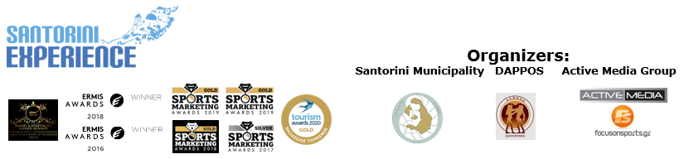

**PRESS RELEASE**

**Santorini Experience: Gold award at**

**2020 Tourism Awards**

Take advantage of the registration discounts

**Athens, June 5, 2020 -** The event, which praises the volcanic island of Cyclades, for its sports, culture, unique architecture, and history, will be held for the **6th consecutive year** on **October 2-4, 2020.** **Santorini Experience** will attract professional and amateur athletes for another year and promote sports and Santorini as a destination, with **respect to the environment and the island’s traditional architecture.** This year’s races will adopt an **eco-friendly** approach, with a strategy that involves **plastic-free and environmentally friendly initiatives**.

**Run with a stunning view of the Caldera**

On **Saturday, October 3, 2020,** participants will have the opportunity to run on the **Caldera,** overlooking the enchanting images of the volcano and the background scenery of **Imerovigli, Firostefani and Oia.** Specifically, the **10 km route** is addressed to runners with an experiencein distances, while the **15 km route “Aristides Alafouzos”** is ideal for those who love strength, endurance, and adrenaline. All routes start from the desalination plant in Oia, mainly including parts of soil, and finish in Oia. The breathtaking routes are designed by the former marathon runner, Greek classic route record holder, running trainer and director of All About Running, **Nikos Polias**.

**Swim in the unparalleled volcanic landscape**

On **Sunday, October 4, 2020,** participants will have the opportunity to swim from the **volcano** to the **old port of Fira**, while having the imposing view of the island in front of them, in the **1.5 miles open water swimming race (2.4 km).** The event will look after all athletes by adding the high-quality safety **lifeguard buoy**, giving them an extra motive to choose Santorini Experience. The swimming route will be held, as every year, with absolute safety in the captivating waters of Santorini, where the **average water temperature** in October, reaches **20-22 degrees Celsius.** **Lifeguard Patrol’s** specialized lifeguards and lifeboats will contribute to the safety of the race for another year. Different **categories** will be formed depending on the final number of entries, while a separate category for those wearing wetsuits will be added. The race will be held under the technical direction of Greek national swimming coach with Olympic and World Championship distinctions, **Nikos Gemelos,** with the **approval of the Hellenic Swimming Federation,** according to **FINA regulations.**

Enjoy the event’s **teaser video** through the following link: [**https://youtu.be/JI9skJenaEc**](https://youtu.be/JI9skJenaEc)

**At the forefront of the 2020 Tourism Awards for the first time**

The event that has already been distinguished in the past in Greece and abroad, with an international award at the Travel & Hospitality Awards, the Ermis Awards and the Sports Marketing Awards, conquered **for the first time** a top position at the **2020 Tourism Awards.** Specifically, the successful sports tourism event won the **Gold Award** in the category of **Sea Tourism** for implementing its innovative initiatives**.**

In the context of this year’s award, **Santorini Mayor, Mr. Antonios Sigalas** stated, among other things: “*The award given to the event of Santorini Experience by the acclaimed Tourism Awards institution, is an exceptional honorary distinction for Santorini. Our Municipality implements a Complete Plan for the Management of Santorini’s Destination, having adopted the strategy of sustainable development with emphasis on the protection of the natural and man-made environment, the emergence of our cultural wealth, innovation, and quality of infrastructure. Our recognition by a tourism excellence institution, such as the Tourism Awards, strengthens the brand of Santorini, reinforces the island’s position among the world’s top destinations and motivates us to continue our actions in the field of quality tourism”.*

Respectively, the **President of the Municipal Sports Cultural Environmental Organization of Santorini (DAPPOS), Mr. Vassilios Alafouzos** stressed: *“This award belongs to all citizens of Santorini that have embraced the event. On our behalf, we will support any effort that fosters sports and promotes Greek tourism”.*

**Register today** for the **15km “Aristides Alafouzos” and 10km** running routes, as well as the 1.5 miles swimming route and take advantage of the **early bird prices with a 25% discount. The offer is valid until 31/7.** The event, always prioritizing the participants themselves, **offers a refund of their registration costs until August 31.**

**Registration link:** [**https://www.myrace.gr/event/2408/registrations.html**](https://www.myrace.gr/event/2408/registrations.html)

Driven by this unprecedented situation, the top sports tourism event **Santorini Experience** is expected to support, this year more than ever, **Santorini’s** **sports tourism** during the month of October through a number of actions.

As every year, the event will be held, in accordance with the **strict standards** set by the Greek Ministry of Tourism, the General Secretariat of Sports and all relevant sports Federations. Santorini Experience will be planned and delivered based on the protocol of races, which will ensure public health and safety of all parties involved.

Besides, the **safety and health** of all participants remains its main priority.

For another year, **Luanvi** is the event’s **official sports supplier.**

**Boatmen Union Santorini** is the event’s **official supporter.**

**Avance** is the **official rental partner.**

Santorini Experience is **assisted** by **Lifeguard Patrol.**

Up to this point, this year’s event is supported with **special offers and prices** by the following **hospitality sponsors**: **Athina Luxury Suites, Santo Maris Oia Luxury Suites & Spa, Canaves Oia, West East Suites, Andronis Arcadia, K&K Unique Holiday Homes, Sienna Resort, Marvarit Suites, Santo Houses, 270 Oia’s View, Fanouris Condo, Monolithia, Casa Iphigenia, La Mer Suites & Spa, Antinea Suites & Spa, Beach Boutique Hotel, Bloom Travel, Loizos Stylish Residencies, Iokasti Villa, Olive Cave Houses, Panorama Studios & Suites, Esperas Santorini** and **Mesana Stone House,** while collaborations continue.

**Tangopapas.com** is the event’s **travel partner.**

**Santorini Experience** is co-organized by the **Municipality of Santorini, Municipal Sports Cultural Environmental Organization of Santorini (DAPPOS)** and **Active Media Group.**

More info at: [www.santorini-experience.com](http://www.santorini-experience.com/)

Sports Production: **Active Media Group**

**Official Hashtag:** #SantoriniExperience

**Information for the editors:**

**Press Office Contact:**

Tel.: +30 210 9343020, fax: +30 210 9316505

e-mail: [pr@activemedia.com.gr](mailto:pr@activemedia.com.gr)

**Website:** [www.santorini-experience.com](http://www.santorini-experience.com/)

**Facebook Page:** <https://www.facebook.com/SantoriniExperience>

**Instagram Page:** <https://www.instagram.com/santoriniexperience/>

**Twitter Account:** <https://twitter.com/Sant_Experience>

**YouTube Channel:** <https://www.youtube.com/channel/UCGconq7q45TYim8qFg71XlA>



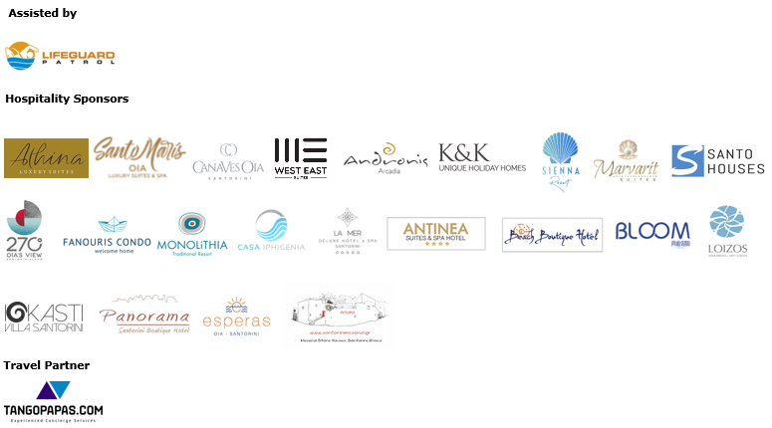



**Member of:**



**Approved by the Hellenic Swimming Federation**

