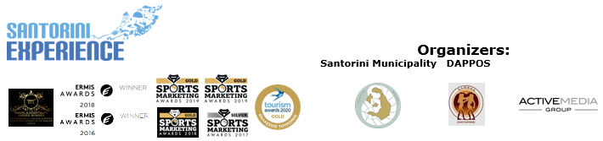

**PRESS RELEASE**

**Swimming in the enchanting waters of the Aegean Sea**

Discover Santorini’s unique offers

**Athens, August 21, 2020 –** Preparations for **Santorini Experience** continue as the great sport tourism event approaches its **6th year,** on **October 2-4, 2020.** **Santorini,** which is recognized among the top destinations around the world, will attract professional and amateur athletes once again this year, offering them unique moments of sports and tourism combined.

The **trail running** and **open water swimming** races that will be held on **October 3 and October 4,** respectively, will have an **eco-friendly approach,** through a **strategy** that incorporates **plastic-free actions,** always placing the **safety of all participants as its main priority.**

**The history of the volcano**

The **volcano of Santorini** is one of the largest underwater active volcanoes in the world and perhaps the **only volcano whose Caldera reaches the sea.**

From the volcanic eruptions of ancient times, which even connected Santorini with the myth of the **lost Atlantis,** to the recent earthquakes, the history of Santorini is directly connected to its “restless” territory and its volcanoes. Parts of Santorini’s volcano are: Nea Kameni (1707-1711 AD), Palea Kameni (46-47 AD), the underwater volcano Columbus (active) (1650 AD) and Christiana Islands. The exciting swimming race of **Santorini Experience** will take place in the sea gap between Thira and Thirasia, which was formed during the Minoan eruption that took place in 1613 BC, featuring a **depth of more than 1,000 meters.**

**Swim in the deep blue waters of stunning Santorini**

In the morning of **Sunday October 4, 2020**, participants of Santorini Experience will have the opportunity to swim **over the lost Atlantis,** according to **Plato,** on the **mesmerizing 1.5 miles (2.4 km) route** from the **volcano** to the **old port of Fira.** Swimmers will enjoy the imposing view of the island in the warm waters of the volcano, at the **open water swimming race by Vikos.** The event will look after all athletes by providing high-quality safety **lifeguard buoys**. The swimming route will be held, as every year, with absolute safety in the captivating waters of Santorini, where the **average water temperature** in October, reaches **20-22 degrees Celsius.** **Lifeguard Patrol’s** specialized lifeguards and rescue boats will contribute to the safety of the race for another year. Different **categories** will be formed depending on the final number of entries and a separate category for those wearing wetsuits will be added too. The race will be held under the technical direction of Greek national swimming coach with Olympic and World Championship distinctions, **Nikos Gemelos,** with the **approval of the Hellenic Swimming Federation,** according to **FINA regulations** and the **event’s health protocol** in accordance with the instructions of the special scientists-collaborators of the Hellenic Swimming Federation, based on the epidemiological data and the suggestions of the Health Committee of the General Secretariat of Sports.

You may find all **technical details** of the **swimming route** here: <https://bit.ly/31gUQGW> and discover the exciting route in the following **video:** <https://youtu.be/FKyh6_hoL4g>

Moreover, you may enjoy a **video** with **statements** by **top swimmers and representatives of open water swimming** from last year’s event: <https://youtu.be/hyzO7Dx6ItA>

**Registration offers**

The event, always prioritizing the participants themselves, **offers a refund of their registration costs until August 31. Register today** for the **“Aristides Alafouzos” 15km and 10km** running routes, as well as the **1.5 miles** swimming route at the following **link:** [**https://www.myrace.gr/en/event/2408/registrations.html**](https://www.myrace.gr/en/event/2408/registrations.html)

The event will be held, in accordance with the **strict standards** set by the Greek Ministry of Tourism, the General Secretariat of Sports and all relevant sports Federations. Santorini Experience will be planned and delivered based on the protocol of races, which will ensure public health and safety of all parties involved. Moreover, the **health and safety** of all participants remains the event’s main priority. The 10km race is organized along with **AS Ifestos Thiras** and **EAS SEGAS Cyclades Region** and **approved by the Hellenic Athletics Federation (SEGAS).**

**Santorini Experience** has joined the Greek actions of the **#BeactiveHellas 2020** programme of the European Commission and is held **under the auspices of the General Secretariat of Sports.**

The award-winning **Active Media Group** is responsible for the event’s **Sports Production,** and it is worth noting, that the event’s **Official Hashtag #SantoriniExperience,** has created its own unique trend on social media.

**Accommodation packages at great prices and for all preferences**

Up to this point and in these **difficult times**, this year’s event is supported with **amazing offers and prices** by the following **hospitality sponsors:** **Athina Luxury Suites, Santo Maris Oia Luxury Suites & Spa, Canaves Oia, Katikies Santorini, Andronis Arcadia, West East Suites, K&K Unique Holiday Homes, Folia Bianca,** **Cocoon Suites, Marvarit Suites, Iriana Suites, Nefeles Luxury Suites, Sienna Resort, Santo Houses, Memories Hotel, 270 Oia’s View, Cori Rigas Suites, Uma Ray Suites, Loizos Stylish Residencies, Monolithia, Fanouris Condo, Epavlis Hotel, Iokasti Villa, Olive Cave Houses, Panorama Boutique Hotel, Esperas Santorini** and **Santorini Hospitality**. Whether you wish to stay in the **Caldera,** **Fira,** **Imerovigli,** **Oia,** or in the beautiful **Pyrgos,** **Monolithos, Akrotiri, Kamari, Messaria, Emporio, Megalochori** or at the endless beach of **Perissa** and **Perivolos, Santorini** has everything.Participants may opt to stay in a room for two people, in a house for 4-6 people or in a villa with a pool for 4-10 people, amongst the many other options of Santorini.

Check the event’s specially designed **page** and discover the **accommodation packages** and **special offers** which are valid for the participants: <https://bit.ly/38QAvdw>

**Travel to Santorini Experience 2020 with safety**

All those traveling to the island by ferry, will be able to enjoy the safety and comfort of **Blue Star Ferries** once again this year. The top Greek shipping company offers **40% discount on the ferry tickets, from/to Santorini** **and 30% discount on vehicles** to all those visiting the event and the islandduring that period.Each person who has completed his/her registration is entitled to the **same discount for 3 more people,** if these are his/her escorts, **or for 4 people** if these are family members.

Moreover, the top Greek rental company **Avance,** as the event’s **official car rental partner** provides participants of Santorini Experience with an opportunity to make their reservation, with a **15% discount** on the official price list, for any vehicle of their choice regarding their travel to the island during the period of the event.

For more information on **Blue Star Ferries** **ferry tickets’ offers** and **car rentals with Avance** for **Santorini Experience**: [**https://bit.ly/2FHS0Cq**](https://bit.ly/2FHS0Cq)

**Athina Luxury Suites, Vikos Natural Mineral Water** and **Blue Star Ferries** are the event’s **official sponsors.**

**Luanvi** is the event’s **official sports supplier** for another year.

**Boatmen Union Santorini** is the event’s **official supporter.**

**Avance** is the **official car rental partner.**

**Messinian Spa** is the event’s **official beauty partner.**

**Premium TV partner:** SKAI

**Premium media partner:** 24MEDIA

**Red Swim Academy, Swim Academy, Leandros** and **Swimmingclub.gr** are the **athletic partners** of Santorini Experience.

The event is **assisted** by **Lifeguard Patrol, Voluntary Lifeguards of Santorini, Atlantis Dive Center, Santorini Nautical Club** and **Caldera Yachting.**

**Tangopapas.com** is the event’s **travel partner.**

**Santorini Experience** is co-organized by the **Municipality of Santorini, Municipal Sports Cultural Environmental Organization of Santorini (DAPPOS)** and **Active Media Group.**

More info at: [www.santorini-experience.com](http://www.santorini-experience.com/)

**Information for the editors:**

**Press Office Contact:**

Tel.: +30 210 9343020, fax: +30 210 9316505

e-mail: [pr@activemedia.com.gr](mailto:pr@activemedia.com.gr)

**Website:** [www.santorini-experience.com](http://www.santorini-experience.com/)

**Facebook Page:** <https://www.facebook.com/SantoriniExperience>

**Instagram Page:** <https://www.instagram.com/santoriniexperience/>

**Twitter Account:** <https://twitter.com/Sant_Experience>

**YouTube Channel:** <https://www.youtube.com/channel/UCGconq7q45TYim8qFg71XlA>

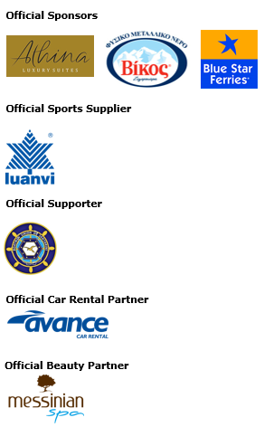

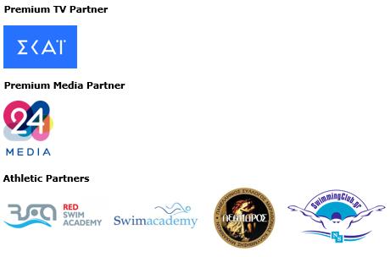

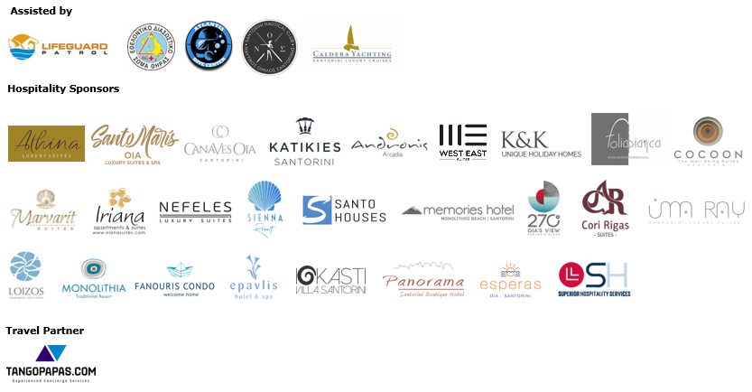







**Member of:**





**Approved by the Hellenic Swimming Federation**

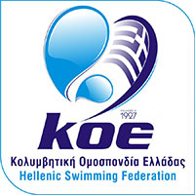

**10km running race is co-organized with AS Ifestos Thiras and EAS SEGAS Cyclades Region and approved by the Hellenic Athletics Federation (SEGAS)**





