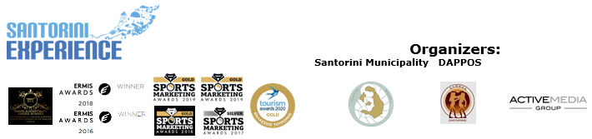

**PRESS RELEASE**

**Running with a breathtaking view**

Visit the most famous island in the world and

take advantage of the accommodation & transportation offers

**Athens, July 14, 2020 – Santorini** is the **ultimate destination** for every traveler around the world. Known for its iconic **Cycladic architecture,** unique **sunsets** and distinctive sandy **beaches** formed by the **volcanic** activity, Santorini invites you to explore the island all year round. This **October** you have one more reason to discover all these features by combining your visit with the ultimate sporting experience of **Santorini Experience.**

The top sports tourism event returns for the **6th consecutive year** from **October 2-4, 2020.** Through its exciting **open water swimming** and **trail running** activities, **Santorini Experience,** continues to attract global interest of professional and amateur athletes on a yearly basis.

The races will have an **eco-friendly approach,** through a **strategy** that incorporates **plastic-free actions,** always with respect to the natural environment of the island.

**Run along the Caldera with a view of the Volcano**

The **routes** of **Santorini Experience** have been designed on the enchanting path that connects Oia with Fira, featuring breathtaking views. Runners will discover the totally white, majestic settlements built on the edge of the Caldera, with the picturesque cobbled streets and the impressive churches. Athletes will run at a maximum altitude of 334 meters above sea level, with a wonderful view of the clear blue waters of the Aegean and the islet of Nea Kameni while they will find themselves only a breath away from the sky.

The running races will be held on **Saturday, October 3, 2020,** with a background scenery of **Imerovigli, Firostefani** and **Oia.** The **10km** route is addressed to the most experienced in distances, while the **“Aristides Alafouzos” 15 km route** is ideal for those who prefer strength, endurance, and adrenaline. All routes start and finish at the desalination plant in Oia and the ground mainly includes parts of soil.

The exciting routes overlooking the volcano are designed by the former marathon runner, Greek classic route record holder, running trainer and director of All About Running, **Nikos Polias**.

You may check all **running routes’ details** here: <https://bit.ly/2OiSU9h>

Enjoy the breathtaking view through the following **video**: <https://youtu.be/6Ivv_lt20UM>

**Registration offers**

**Register today** for the **“Aristides Alafouzos” 15km and 10km** running routes, as well as the **1.5 miles** swimming route and take advantage of the **early bird prices with a 25% discount. The offer is valid until 31/7.** The event, always prioritizing the participants themselves, **offers a refund of their registration costs until August 31.**

**Registration link:** [**https://www.myrace.gr/en/event/2408/registrations.html**](https://www.myrace.gr/en/event/2408/registrations.html)

As every year, the event will be held, in accordance with the **strict standards** set by the Greek Ministry of Tourism, the General Secretariat of Sports and all relevant sports Federations. Santorini Experience will be planned and delivered based on the protocol of races, which will ensure public health and safety of all parties involved. Moreover, the **health and safety** of all participants remains the event’s main priority. The 10km race will be organized along with **AS Ifestos Thiras** and **EAS SEGAS Cyclades Region** and **approved by the Hellenic Athletics Federation (SEGAS).** The **1.5 miles (2.4 km) open water swimming** race will be held with the **approval of the Hellenic Swimming Federation,** according to **FINA regulations.**

**Santorini Experience** has joined the Greek actions of the **#BeactiveHellas 2020** programme of the European Commission and is held **under the auspices of the General Secretariat of Sports.**

The award-winning **Active Media Group** is responsible for the event’s **Sports Production,** while the event’s **Official Hashtag #SantoriniExperience,** has created its own unique trend on social media.

**Accommodation packages at great prices and for all preferences**

Up to this point and in these **difficult times**, this year’s event is supported with **amazing offers and prices** by the following **hospitality sponsors:** **Athina Luxury Suites, Santo Maris Oia Luxury Suites & Spa, Canaves Oia, Andronis Arcadia, West East Suites, K&K Unique Holiday Homes, Marvarit Suites, Folia Bianca, Iriana Suites, Nefeles Luxury Suites, Sienna Resort, Memories Hotel, Uma Ray Suites, Santo Houses, 270 Oia’s View, Fanouris Condo, Monolithia, Epavlis Hotel, Loizos Stylish Residencies, Iokasti Villa, Olive Cave Houses, Panorama Boutique Hotel, Cori Rigas Suites, Esperas Santorini** and **Santorini Hospitality**. Whether you wish to stay in the **Caldera,** **Fira,** **Imerovigli,** **Oia,** or in the beautiful **Pyrgos,** **Monolithos, Akrotiri, Kamari, Messaria, Emporio, Megalochori** or at the endless beach of **Perissa** and **Perivolos, Santorini** has everything.Participants may opt to stay in a room for two people, in a house for 4-6 people or in a villa with a pool for 4-10 people, amongst the many other options of Santorini.

Check the event’s specially designed **page** and discover the **accommodation packages** and **special offers** which are valid for the participants: <https://bit.ly/38QAvdw>

**40% discount on the already low fares of ferry tickets**

All those traveling to the island by ferry for the 6th Santorini Experience, will be able to enjoy the safety and comfort of Blue Star Ferries once again this year**.** The top Greek shipping company offers **40% discount on the ferry tickets, from/to Santorini** **and 30% discount on vehicles** to all those visiting the event and the islandduring that period.Each person who has completed his/her registration is entitled to the **same discount for 3 more people,** if these are his/her escorts, **or for 4 people** if these are family members.

With consistency and responsibility, Blue Star Ferries continues to implement all necessary measures on all its ships before and during the trip, in order to ensure the health of both their passengers and their staff. More information: <https://bit.ly/2Ct2vYA>

**15% discount on car rentals**

The top Greek rental company **Avance,** as the event’s **official car rental partner** provides participants of Santorini Experience with an opportunity to make their reservation, with a **15% discount** on the official price list, for any vehicle of their choice regarding their travel to the island during the period of the event. In terms of bookings, participants need to send an email to **reserv(at)avance.gr**

**Santorini Experience** is co-organized by the **Municipality of Santorini, Municipal Sports Cultural Environmental Organization of Santorini (DAPPOS)** and **Active Media Group.**

More info at: [www.santorini-experience.com](http://www.santorini-experience.com/)

**Athina Luxury Suites** and **Blue Star Ferries** are the event’s **official sponsors.**

**Luanvi** is the event’s official sports supplier for another year.

**Boatmen Union Santorini** is the event’s **official supporter.**

**Avance** is the **official car rental partner.**

**Red Swim Academy, Swim Academy, Leandros** and **Swimmingclub.gr** are the **athletic partners** of Santorini Experience.

The event is **assisted** by **Lifeguard Patrol, Voluntary Lifeguards of Santorini, Atlantis Dive Center, Santorini Nautical Club** and **Caldera Yachting.**

**Tangopapas.com** is the event’s **travel partner.**

**Information for the editors:**

**Press Office Contact:**

Tel.: +30 210 9343020, fax: +30 210 9316505

e-mail: [pr@activemedia.com.gr](mailto:pr@activemedia.com.gr)

**Website:** [www.santorini-experience.com](http://www.santorini-experience.com/)

**Facebook Page:** <https://www.facebook.com/SantoriniExperience>

**Instagram Page:** <https://www.instagram.com/santoriniexperience/>

**Twitter Account:** <https://twitter.com/Sant_Experience>

**YouTube Channel:** <https://www.youtube.com/channel/UCGconq7q45TYim8qFg71XlA>





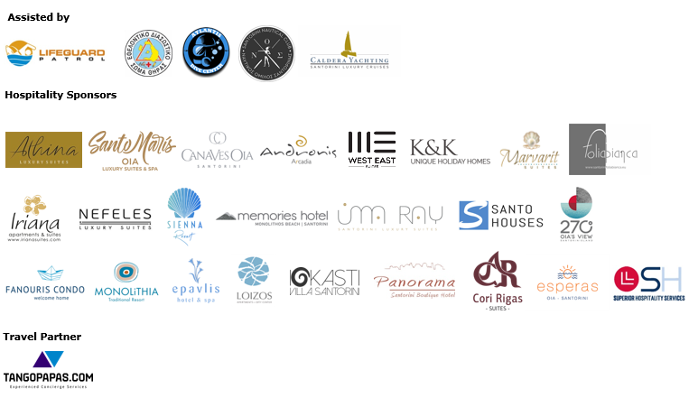







**Member of:**





**Approved by the Hellenic Swimming Federation**

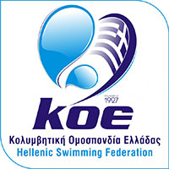

**10km running race is co-organized with AS Ifestos Thiras and EAS SEGAS Cyclades Region and approved by the Hellenic Athletics Federation (SEGAS)**



---

